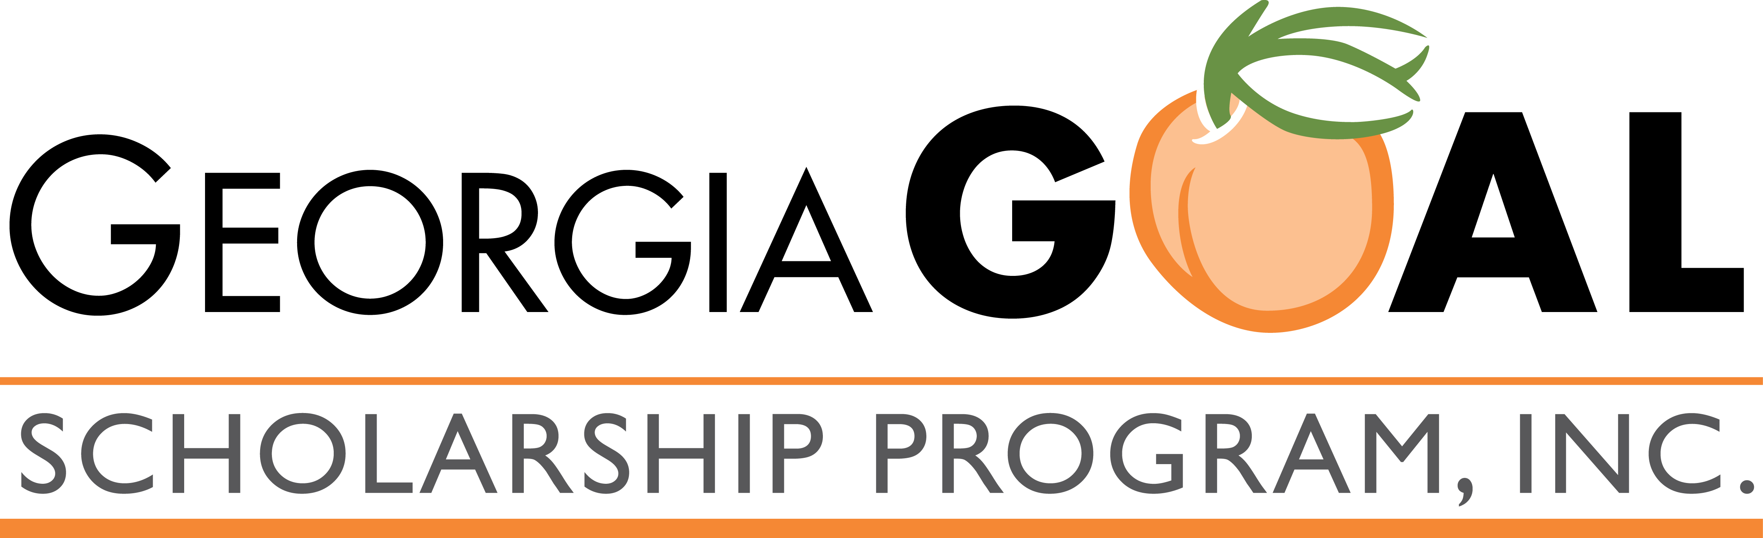
Georgia GOAL Scholarship Program
Tuition Assistance Application

Georgia GOAL Scholarship Program, Inc. does not accept scholarship applications directly. Parents desiring to apply for a scholarship should complete the following information and submit it directly to Shannon Williams at Aquinas High School. While completion and submission of this form does not guarantee receipt of a GOAL Scholarship, it is the initial step in the process. In awarding scholarship funds, Aquinas High School will work closely with its existing tuition assistance office and scholarship committee.

To qualify for receipt of a GOAL Scholarship, a student must be a Georgia resident who is currently enrolled in, and has attended a Georgia secondary or primary public school for a least 6 weeks* immediately prior to receiving a scholarship or tuition grant under this law, or who is eligible to enroll in a qualified Pre-K4, Kindergarten, or 1st grade program.

*The six week attendance requirement may be waived in the following cases:
- A student is or would be assigned to a public school that the Office of Student Achievement determines to be a low-performing school based on the school attendance zone of his or her primary residence, or
- A student is the subject of officially documented cases of school based physical violence or student related verbal abuse threatening physical harm, or
- A student was enrolled in an official home study program for at least one year immediately prior to receiving a scholarship or tuition grant under this law.

Student Name: ________________________________________

Date of Birth: _________________

Applying for Grade: ______

Parent(s) or Guardian(s) Name(s): ____________________________________________

Street Address: ___________________________________________________________

City: ____________________________ State: _______ Zip Code: ____________

Phone: ______________________ Email Address: _________________________

We understand that we are authorizing Shannon Williams to verify any of the information in this tuition assistance application and understand that all information is subject to investigation. We declare that the information represented on this form, to the best of our knowledge and belief, is true, correct, and complete.

_____________________________________________ _______________
Signature of Parent(s) or Guardian(s) Date
Information and Documentation Required

GOAL requires the following to be submitted to Aquinas High School to process the request for scholarship funding:

- Proof of Income:
  - Federal Tax Return (pages 1-2)
  - Do you have any non-taxable income, including any of the following? If so, please list the amounts below:
    - Annual Child Support Received __________
    - Annual Workers' Compensation Received __________
    - Annual Allowances Received for Housing, Food & Living Expenses __________
    - Other Annual Untaxed Income & Benefits __________

- Proof of Eligibility:
  - Proof of Public School Enrollment (report card)
  - Birth Certificate (only applicable to students eligible for Pre-K4, Kindergarten, or 1st grade)
  - Proof of Another HB 1133 Scholarship Award
  - Proof of Home School or Low-Performing Public School

- If desired, any additional supporting documentation to demonstrate the need for tuition assistance

Please explain any current financial conditions which differ from that reported on your latest Federal Income Tax Return. Use the reverse side, if needed.

Applicants receiving a GOAL Scholarship must reapply via the school on a yearly basis for consideration. Funds are awarded each year based on need and availability. GOAL Scholarship recipients must maintain academic and behavioral standards set forth by Aquinas High School.

If further assistance is needed, contact Shannon Williams at swilliams@aquinashighschool.org. To learn more about the Georgia GOAL Scholarship Program, please visit www.goalscholarship.org.

Aquinas High School admits students of any race, color, and national or ethnic origin.

